CC-215-L: Database Systems Lab
BS(IT-24)
LAB – 04
The objective of this lab is to:
- Window Functions
- Joins
- Previous SQL Content
COURSE & LAB INSTRUCTOR: Dr. Asif Sohail
LAB TIMING : 90 MINS
TOTAL MARKS : 45
Task 01: [15 marks]
- Display the employee's name along with the name of their manager. For employees who do not have a manager, display NULL in place of the manager’s name.

- Display the name, salary grade, and job title of all employees whose job is ‘MANAGER’, based on the salary range defined in the SALGRADE table.

- Write an SQL query to display the name of the manager and number of employees working under each manager.
- Display each employee’s employee number, name, department number, and salary, along with their salary rank within the department, where the highest-paid employee in each department has rank 1.

- Write the query to find employees who earn more than the average salary of their department.
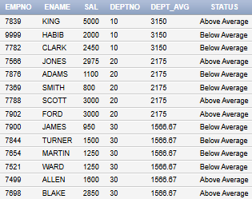

- Write an SQL query to retrieve employees whose salaries do not fall within the ranges specified in the salgrade table. Display their grade as “F”.

- Use the window function to find the second lowest salary in the whole organization .

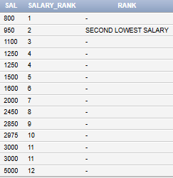
- Display the employee names along with the name of departments they work in.
- Get such Employees who have no manager.(You must use Join)
(Hint: You can join emp with itself)
- Display the name of the employee along with the location of the department work in
Task 02: [16 marks]

- Include a query that compares the sal of each employee with the average sal of the employees with same job. The output is ename, job, sal, avg-sal, status.
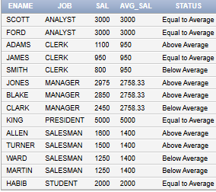

- Display each employee’s name, their manager’s name, department name, salary, and the difference between their salary and the department’s average salary

- Display the average salary for each salary grade, but include only those grades where the average salary is greater than 1500.The result should show the salary grade and its average salary, sorted in ascending order of salary grade.
- Display Jobs with total number of hirings.

- List the employees based on the number of vowels in their names, with the employee having the highest number of vowels ranked first.

- Display each department number, along with a list of all job titles present in that department and the total salary earned by employees in that department, sorted in ascending order of department number
- Return the maximum average salary of the department.

- Display each employee’s name, department number, job title, and salary.
Along with that, show:
- their rank within the department based on salary,
- their overall company rank based on salary, and
- their seniority within their job based on hire date.
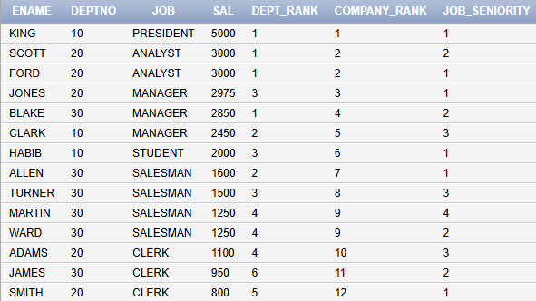

- Find the employee with the third highest salary in each department.
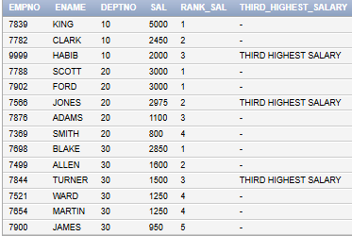

- Display each department’s total salary, average salary, highest salary, and number of employees, along with the department’s rank based on total salary.
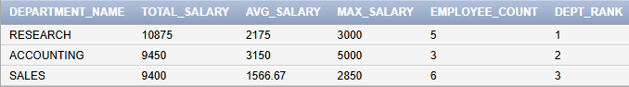
Task 03: [9 marks]
- Write a query that lists departments and, for each department, concatenates the names of employees who have salaries above the department's average salary. The concatenated list should be sorted by the reverse alphabetical order of the employee names, and all names should be converted to lowercase. If there are no employees with salaries above the average for that department, display "NO HIGH SALARY EMPLOYEES" for that department.
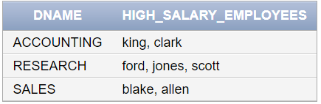
- Write a SQL query to display each employee’s name, job title, department name, manager’s name, salary, and commission (if any).
Additionally, show:
- Their position rank within the entire company based on salary using a window function.
- Their rank within their department based on salary.
- Their total earnings (salary + commission, treating nulls as 0).
- The percentage contribution of each employee’s salary to their department’s total salary.
- The length of their name, reversed name, and a formatted label like "KING - PRESIDENT (DEPT: ACCOUNTING)".
- For each department in the company, write an Oracle SQL query to display:
  - Department number.
  - Total salary expense of the department.
  - Average salary of the department (rounded to 2 decimal places).
  - Maximum salary in the department.
  - The difference between the department’s average salary and the company-wide average salary, formatted as:
  - +value if the department average is above the company average,
  - -value if below,
  - 0 if equal
  - Rank of the department based on average salary, with the highest average ranked first.
Task 04: [5 marks]
VIVA VOCE

